**ADVANCED MULTIVARIABLE CALCULUS**

**Multiple Integration**

* When **multiple variables** are involved in an **integral equation**, we call it ***multiple integration***.
* **Double integration** means **two** variables are involved.

**Evaluation of Double Integration**

* We do it using **Fubini’s theorem**.
* There are **two** methods to perform it.

**Method I:**

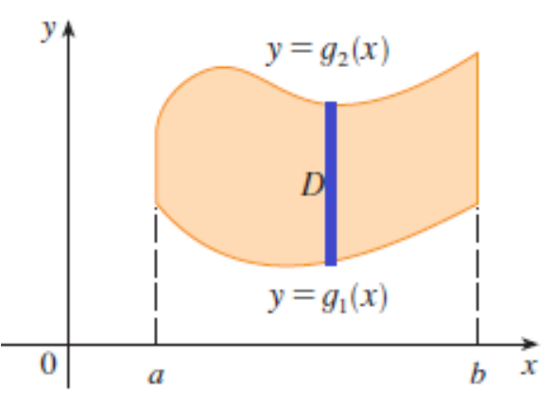

**Limit of x = a to b**

**Limit of y = g1(x) to g2(x)**

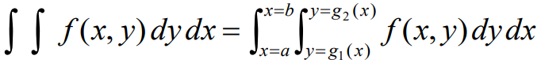

**Method II:**

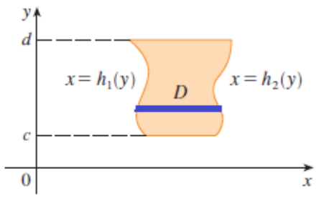

**Limit of x = h1(y) to h2(y)**

**Limit of y = c to d**

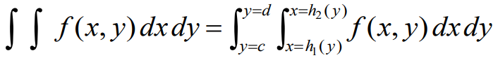

**For example:**

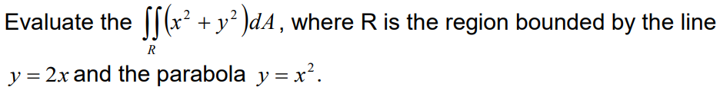

**Solution:**

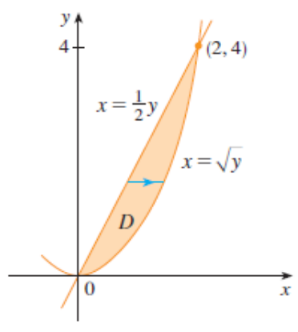

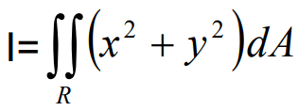

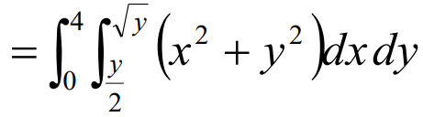

**OR**

